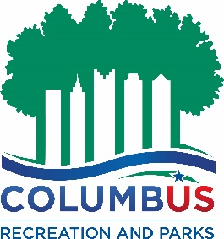

COLUMBUS RECREATION AND PARKS
PERMIT AND RENTAL SERVICES SECTION
SHELTERHOUSE Cancellation Policy

Any cancellation requested 30 calendar days or more prior to the event date will result in a cancellation fee equal to 50% of the total permit fee. Any cancellation requested less than 30 calendar days prior to the event date will result in a cancellation fee of 100% of the total permit fee.
Alcohol Service Agreement fees are non-refundable. All cancellations must be requested Monday through Friday, excluding all City Holidays, between the hours of 8:00am and 4:00pm.

Changes, including requests for additional time, may not be considered less than 15 calendar days prior to the event.

New rental requests and requests for additional time in association with an existing rental made less than 15 calendar days prior to the event are not guaranteed to be accommodated.

If you have any questions or concerns about the rules, cancellation policy, or require any additional information in regards to your rental, please contact the Permit and Rental
Services Section (614-645-3337) prior to your scheduled event (Monday through Friday
8:00AM to 4:00PM).

**This Policy is Subject to Change Without Notice

